www.sportsandspinesphysio.com.au
Ph: 0403946670

PATIENT DETAILS
Title___________First Name_________________ Surname___________________________
Preferred Name ___________________________ Date of Birth ________________________
Address ___________________________________
Suburb ____________________________________ Postcode _________________________
Email______________________________________
Home Phone _______________________________ Mobile Phone ______________________
Emergency Contact (Name and number) ___________________________________________
Health Fund ________________________________ R/L Handed (please circle)
Occupation ________________________________ Interests ___________________________
GP ______________________________________ Contact No __________________________
Please circle how you heard about us? Website/Directory/Media Advertisement/Community event or Friend/Family member . If friend or family, who may we thank? _________________________

GENERAL CASE HISTORY
What is the main purpose of today’s visit? ____________________________________________
______________________________________________________________________________
List any treatments and therapies you are having/had for this _____________________________
______________________________________________________________________________
Have you sought a GP or any other Health Professional for your current problem? ____________
______________________________________________________________________________
Have you had Physiotherapy care before? If so, when was your last visit? ___________________
Relevant Imaging Details and Other Investigations _____________________________________
______________________________________________________________________________

Past Medical History _________________________________________________________
__________________________________________________________________________
Family Medical History (past/present) ____________________________________________ __________________________________________________________________________
Surgery and/or Injuries (past/present) ____________________________________________
__________________________________________________________________________
Mark Areas of pain/symptoms you are currently experiencing:
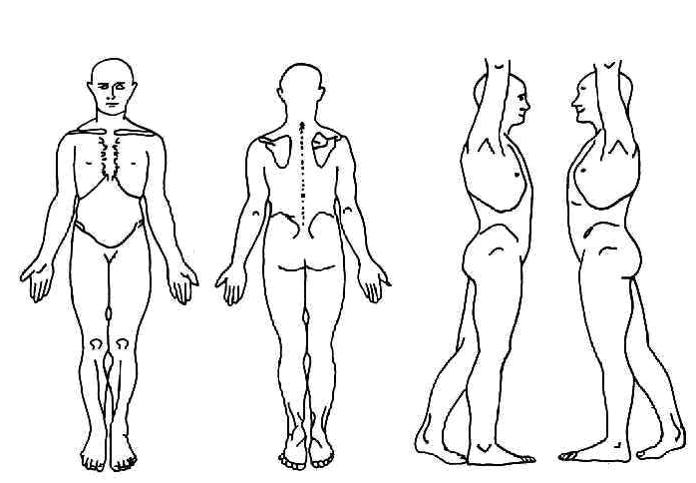

Treatment at Sports and Spines
Your physiotherapist will discuss it with you individually and will ask you to sign a Consent To Treatment Form prior to any treatment being given.
Your therapist will discuss details of your diagnosis and management plan. You are encouraged to ask questions about the treatment proposed,
terminology used, or treatment options available to you.
Treatment may include the following:
• Manual therapy, Joint Mobilisations/Manipulations
• Heat/Ice Therapy
• Dry Needling
• Soft/deep tissue, Trigger Point Therapy and Myofascial Releases
• Exercise Rehabilitation Programs including stretches
• Taping
Research to date has shown the above treatments listed to be a safe and effective management to address short and long term symptoms and injuries.
The risk of injuries, complications or adverse reactions from physiotherapy or remedial care is minimal. In a minority of cases treatment symptoms
may heighten, resulting in temporary soreness, tenderness or mild discomfort. In some instances you may experience fatigue, headaches, light-headedness, nausea and/or dizziness following treatment. The symptoms usually resolve completely within 24 hours after the treatment.
The purpose of this document is to provide you with the information necessary to consent to treatment, including spinal manipulations. All
information provided will be kept confidential within the clinic.
I authorize the information given regarding my medical history and personal details to be accurate and current and any change to details is my responsibility to disclose to my practitioner.

Signature Date

